2021 Water Quality Report for The Village of Lake Orion
Water Supply Serial Number: 3740
This report covers the drinking water quality for The Village of Lake Orion for the 2021 calendar year. This information is a snapshot of the quality of the water that we provided to you in 2021. Included are details about where your water comes from, what it contains, and how it compares to United States Environmental Protection Agency (USEPA) and state standards.
Your water comes from the Detroit Water Treatment Plant north of Port Huron. The plant draws surface water from Lake Huron in the plant for treatment through a 16-foot diameter tunnel, which extends five miles out into Lake Huron. The average depth of the pipe is 190 feet, and at the intake it is 45 feet above the bottom of the lake. The State performed an assessment of our source water to determine the susceptibility or the relative potential of contamination. The susceptibility rating is on a seven-tiered scale from "very-low" to "very-high" based on geologic sensitivity, well construction, water chemistry and contamination sources.
There are no significant sources of contamination in our water supply.
If you would like to know more about this report, please contact: Joe Young at the Village of Lake Orion, 21 E. Church St., Lake Orion, MI 48462. Call by phone to, 248-693-8391. Email the Village Manager at Youngj@lakeorion.org, or visit our website at lakeorion.org.
Contaminants and their presence in water: Drinking water, including bottled water, may reasonably be expected to contain at least small amounts of some contaminants. The presence of contaminants does not necessarily indicate that water poses a health risk. More information about contaminants and potential health effects can be obtained by calling the USEPA’s Safe Drinking Water Hotline (800-426-4791).
Vulnerability of sub-populations: Some people may be more vulnerable to contaminants in drinking water than the general population. Immuno-compromised persons such as persons with cancer undergoing chemotherapy, persons who have undergone organ transplants, people with HIV/AIDS or other immune systems disorders, some elderly, and infants can be particularly at risk from infections. These people should seek advice about drinking water from their health care providers. USEPA/Center for Disease Control guidelines on appropriate means to lessen the risk of infection by Cryptosporidium and other microbial contaminants are available from the Safe Drinking Water Hotline (800-426-4791).
Sources of drinking water: The sources of drinking water (both tap water and bottled water) include rivers, lakes, streams, ponds, reservoirs, springs, and wells. Our water comes from wells. As water travels over the surface of the land or through the ground, it dissolves naturally occurring minerals and, in some cases, radioactive material, and can pick up substances resulting from the presence of animals or from human activity.
Contaminants that may be present in source water include:
- Microbial contaminants, such as viruses and bacteria, which may come from sewage treatment plants, septic systems, agricultural livestock operations, and wildlife.
- Inorganic contaminants, such as salts and metals, which can be naturally occurring or result from urban stormwater runoff, industrial or domestic wastewater discharges, oil and gas production, mining, or farming.
- Pesticides and herbicides, which may come from a variety of sources such as agriculture and residential uses.
- Radioactive contaminants, which can be naturally occurring or be the result of oil and gas production and mining activities.
- Organic chemical contaminants, including synthetic and volatile organic chemicals, which are by-products of industrial processes and petroleum production, and can also come from gas stations, urban stormwater runoff, and septic systems.
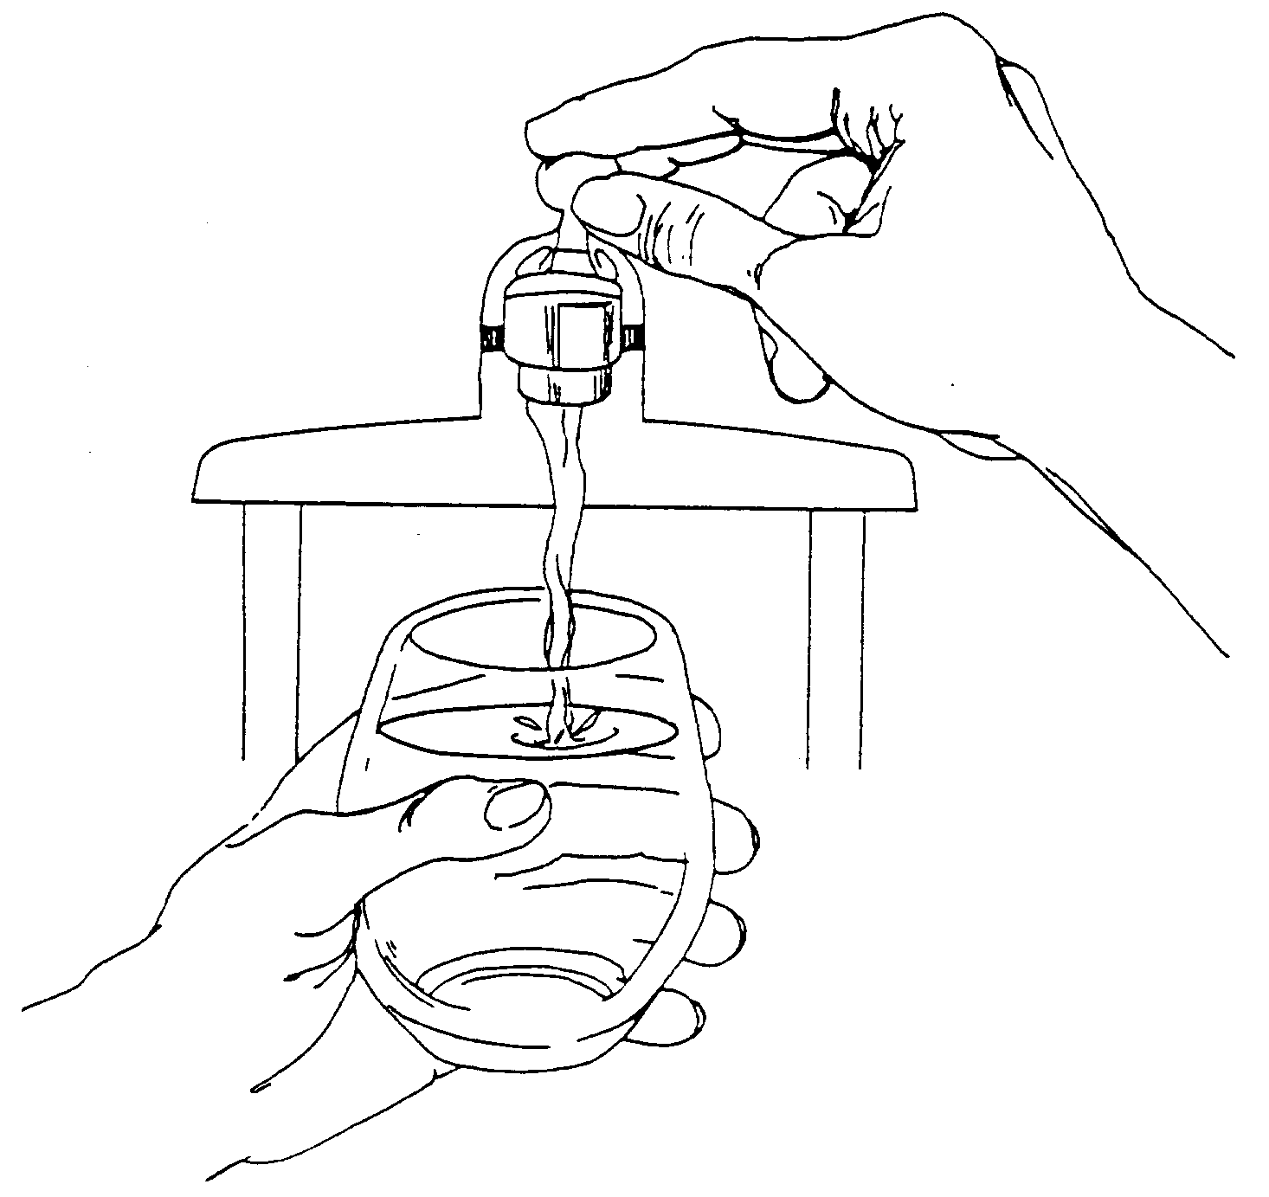
To ensure that tap water is safe to drink, the USEPA prescribes regulations that limit the levels of certain contaminants in water provided by public water systems. Federal Food and Drug Administration regulations establish limits for contaminants in bottled water which provide the same protection for public health.

Water Quality Data
2021 Lake Huron Tap Water Mineral Analysis
Parameter | Units | Max. | Min. | Avg. |  | Parameter | Units | Max. | Min. | Avg.
Turbidity | NTU | 0.11 | 0.04 | 0.07 |  | Chloride | ppm | 10.1 | 8.4 | 9.6
Total Solids | ppm | 164 | 70 | 124 |  | Phosphorus | ppm | 0.48 | 0.36 | 0.40
Total Dissolved Solids | ppm | 148 | 68 | 113 |  | Free Carbon Dioxide | ppm | 8.3 | 4.4 | 5.8
Aluminum | ppm | 0.139 | 0.023 | 0.060 |  | Total Hardness | ppm | 107 | 85 | 98
Iron | ppm | 0.3 | 0.1 | 0.2 |  | Total Alkalinity | ppm | 78 | 72 | 75
Copper | ppm | 0.001 | ND | 0.000 |  | Carbonate Alkalinity | ppm | 0 | 0 | 0
Magnesium | ppm | 8.3 | 6.0 | 7.4 |  | Bi-Carbonate Alkalinity | ppm | 78 | 72 | 74
Calcium | ppm | 27.7 | 20.5 | 25.0 |  | Non-Carbonate Hardness | ppm | 29 | 13 | 24
Sodium | ppm | 16.1 | 4.0 | 5.8 |  | Chemical Oxygen Demand | ppm | 5.0 | ND | 1.9
Potassium | ppm | 1.1 | 0.8 | 1.0 |  | Dissolved Oxygen | ppm | 12.6 | 8.3 | 10.5
Manganese | ppm | ND | ND | 0.000 |  | Nitrite Nitrogen | ppm | ND | ND | 0.0
Lead | ppm | ND | ND | 0.000 |  | Nitrate Nitrogen | ppm | 0.37 | 0.29 | 0.33
Zinc | ppm | 0.003 | ND | 0.001 |  | Fluoride | ppm | 0.80 | 0.59 | 0.67
Silica | ppm | 2.5 | 1.8 | 2.2 |  | pH |  | 7.53 | 7.25 | 7.42
Sulfate | ppm | 22.4 | 17.3 | 19.3 |  | Specific Conductance @ 25 °C | µmhos | 312 | 188 | 222
 |  |  |  |  |  | Temperature | °C | 68.2 | 4.2 | 19.2
The table below lists all the drinking water contaminants that we detected during the 2021 calendar year. The presence of these contaminants in the water does not necessarily indicate that the water poses a health risk. Unless otherwise noted, the data presented in this table is from testing done January 1 through December 31, 2021. The State allows us to monitor for certain contaminants less than once per year because the concentrations of these contaminants are not expected to vary significantly from year to year. All the data is representative of the water quality, but some are more than one year old.

2021 Lake Huron Regulated Detected Contaminants Table
2021 Inorganic Chemicals - Annual Monitoring at Plant Finished Tap
Regulated  Contaminant | Test Date | Unit | Health Goal  MCLG | Allowed Level  MCL | Highest  Level Detected | Range of  Detection | Violation | Major Sources in Drinking Water
Fluoride | 04/13/2021 | ppm | 4 | 4 | 0.62 | n/a | no | Erosion of natural deposit; Water additive, which promotes strong teeth; Discharge from fertilizer and aluminum factories.
Nitrate | 04/13/2021 | ppm | 10 | 10 | 0.31 | n/a | no | Runoff from fertilizer use; Leaching from septic tanks, sewage; Erosion of natural deposits.
Barium | 05-16-2017 | ppm | 2 | 2 | 0.01 | n/a | no | Discharge of drilling wastes; Discharge from metal refineries; Erosion of natural deposits.

Lead and Copper Monitoring at the Customer’s Tap in 2021
Regulated  Contaminant | Unit | Year Sampled | Health Goal  MCLG | Action Level  AL | 90th Percentile Value* | Range of  Individual  Samples  Results | Number of Samples Over AL | Major Sources in Drinking Water
Lead | ppb | 2021 | 0 | 15 | 0 | 0-22 | 1 | Lead services lines, corrosion of household, plumbing including fittings and fixtures; erosion of natural deposits.
Copper | ppm | 2021 | 1.3 | 1.3 | .1 | 0.0-.2 | 0 | Corrosion of household plumbing system; Erosion of natural deposits; leaching from wood preservatives.
* The 90th percentile value means 90 percent of the homes tested have lead and copper levels below the given 90th percentile value. If the 90th percentile value is above the AL additional requirements must be met.

2021 Disinfection Residual - Monitoring in the Distribution System
Regulated  Contaminant | Test  Date | Unit | Health Goal  MRDLG | Allowed Level  MRDL | Highest  Level  RAA | Range of  Quarterly Results | Violation | Major Sources in Drinking Water
Total Chlorine Residual | 2021 | ppm | 4 | 4 | 0.8 | 0.72-0.87 | no | Water additive used to control microbes

2021 Disinfection By-Products - Stage 2 Disinfection By-Products Monitoring in the Distribution System
Regulated  Contaminant | Test Date | Unit | Health Goal  MCLG | Allowed Level  MCL | Highest  Level LRAA | Range of  Quarterly Results | Violation | Major Sources in Drinking Water
(TTHM)  Total Trihalomethanes | 2021 | ppb | n/a | 80 | 45.5 | 32-60 | no | By-product of drinking water chlorination
(HAA5)  Haloacetic Acids | 2021 | ppb | n/a | 60 | 12.45 | 5-17 | no | By-product of drinking water chlorination

2021 Turbidity - Monitored Every 4 Hours at the Plant Finished Water Tap
Highest Single Measurement Cannot Exceed 1 NTU | Lowest Monthly % of Samples Meeting Turbidity Limit of 0.3 NTU (minimum 95%) | Violation | Major Sources in Drinking Water
0.09 NTU | 100% | no | Soil Runoff
Turbidity has no health effects. However, turbidity can interfere with disinfection and provide a medium for microbial growth. Turbidity may indicate the presence of disease-causing organisms. These organisms include bacteria, viruses, and parasites that can cause symptoms such as nausea, cramps, diarrhea and associated headaches.

Regulated Contaminant | Treatment Technique | Typical Source of Contaminant
Total Organic Carbon ppm | The Total Organic Carbon (TOC) removal ratio is calculated as the ratio between the actual TOC removal and the TOC removal requirements. The TOC is measured each quarter and because the level is low, there is no requirement for TOC removal. | Erosion of natural deposits

Radionuclides - Monitored at the Plant Finished Tap in 2014
Regulated Contaminant | Test Date | Unit | MCLG | MCL | Level Detected | Violation | Major Sources in Drinking Water
Combined Radium  Radium 226 and 228 | 5/13/14 | pCi/L | 0 | 5 | 0.86 + 0.55 | no | Erosion of natural deposits

2021 Special Monitoring
Contaminant | Test Date | Unit | MCLG | MCL | Highest Level Detected | Source of Contaminant
Sodium | 4/13/2021 | ppm | n/a | n/a | 4.23 | Erosion of natural deposits
These tables are based on tests conducted by GLWA in the year 2021 or the most recent testing done within the last five calendar years. GLWA conducts tests throughout the year only tests that show the presence of a substance or require special monitoring are presented in these tables. The State allows us to monitor for certain contaminants less than once per year because the concentrations of these contaminants are not expected to vary significantly from year to year. The data is representative of the water quality, but some are more than one year old.
Symbol | Abbreviation | Definition/Explanation
AL | Action Level | The concentration of a contaminant, which, if exceeded, triggers treatment or other requirements which a water system must follow.
°C | Celsius | A scale of temperature in which water freezes at 0° and boils at 100° under standard conditions.
> | Greater than
HAA5 | Haloacetic Acids | HAA5 is the total of bromoacetic, chloroacetic, Dibromoacetic, dichloroacetic, and trichloroacetic acids. Compliance is based on the total.
Level 1 | Level 1 Assessment | A Level 1 assessment is a study of the water system to identify potential problems and determine (if possible) why total coliform bacteria have been found in the water system.
LRAA | Locational Running Annual Average | The average of analytical results for samples at a particular monitoring location during the previous four quarters.
MCL | Maximum Contaminant Level | The highest level of a contaminant that is allowed in drinking water. MCLs are set as close to the MCLGs as feasible using the best available treatment technology.
MCLG | Maximum Contaminant Level Goal | The level of contaminant in drinking water below which there is no known or expected risk to health.
MRDL | Maximum Residual Disinfectant Level | The highest level of disinfectant allowed in drinking water. There is convincing evidence that addition of a disinfectant is necessary for control of microbial contaminants.
MRDLG | Maximum Residual Disinfectant Level Goal | The level of a drinking water disinfectant below which there is no known or expected risk to health. MRLDG’s do not reflect the benefits of the use of disinfectants to control microbial contaminants.
n/a | not applicable
ND | Not Detected
NTU | Nephelometric Turbidity Units | Measures the cloudiness of water.
pCi/L | Picocuries Per Liter | A measure of radioactivity
ppb | Parts Per Billion (one in one billion) | The ppb is equivalent to micrograms per liter.  A microgram = 1/1000 milligram.
ppm | Parts Per Million (one in one million) | The ppm is equivalent to milligrams per liter.  A milligram = 1/1000 gram.
RAA | Running Annual Average | The average of analytical results for all samples during the previous four quarters.
SMCL | Secondary Maximum Contaminant Level | An MCL which involves a biological, chemical or physical characteristic of water that may adversely affect the taste, odor, color or appearance (aesthetics), which may thereby affect public confidence or acceptance of the drinking water.
TT | Treatment Technique | A required process intended to reduce the level of a contaminant in drinking water.
TTHM | Total Trihalomethanes | Total Trihalomethanes is the sum of chloroform, bromodichloromethane, dibromochloromethane and bromoform. Compliance is based on the total.
μmhos | Micromhos | Measure of electrical conductance of water

Information about lead: If present, elevated levels of lead can cause serious health problems, especially for pregnant women and young children. Lead in drinking water is primarily from materials and components associated with service lines and home plumbing. The Village of Lake Orion is responsible for providing high quality drinking water but cannot control the variety of materials used in plumbing components. When your water has been sitting for several hours, you can minimize the potential for lead exposure by flushing your tap for 30 seconds to 2 minutes before using water for drinking or cooking. If you have a lead service line, it is recommended that you run your water for at least 5 minutes to flush water from both your home plumbing and the lead service line. If you are concerned about lead in your water, you may wish to have your water tested. Information on lead in drinking water, testing methods, and steps you can take to minimize exposure is available from the Safe Drinking Water Hotline or at http://www.epa.gov/safewater/lead.
Infants and children who drink water containing lead could experience delays in their physical or mental development. Children could show slight deficits in attention span and learning abilities. Adults who drink this water over many years could develop kidney problems or high blood pressure.
Copper is an essential nutrient, but some people who drink water containing copper in excess of the action level over a relatively short amount of time could experience gastrointestinal distress. Some people who drink water containing copper in excess of the action level over many years could suffer liver or kidney damage. People with Wilson’s Disease should consult their personal doctor.
Our water supply has 26 lead service lines out of a total of 1652 service lines.
Monitoring and Reporting to the Michigan Department of Environment, Great Lakes, and Energy (EGLE) Requirements: The State of Michigan and the USEPA require us to test our water on a regular basis to ensure its safety, we met all the monitoring and reporting requirements for 2021.
We will update this report annually and will keep you informed of any problems that may occur throughout the year as they happen. Copies are available at Lakeorion.org and at Lake Orion Village Hall. This report will not be sent to you.
We invite public participation in decisions that affect drinking water quality. Council meetings are held the 2nd and 4th Monday of each month. Meetings begin at 7:30pm and are held virtually at this time. For more information about your water, or the contents of this report, contact Joe Young, Village Manager, Lake Orion, MI. For more information about safe drinking water, visit the U.S. EPA at http://www.epa.gov/safewater.

